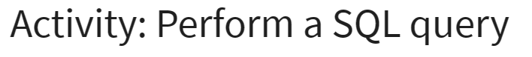

…

…

…

…

…

…

…

**Explanation**

In this SQL activity, I first retrieved all data from the machines table to get a complete overview. Then, I focused on specific details by selecting just the device_id and email_client from the same table. Next, I pulled the device_id, operating_system, and OS_patch_date to check operating system details and patch dates.

Moving to the log_in_attempts table, I first gathered the event_id and country to analyze login attempts by location. I followed this by retrieving the username, login_date, and login_time for detailed login timing insights. I then selected all data from log_in_attempts for a full review.

Finally, I sorted the login attempts first by login_date and then by both login_date and login_time to organize the records chronologically.